**Objectives:**

* Solve trigonometry questions, relating to **right triangles**, using these ratios:

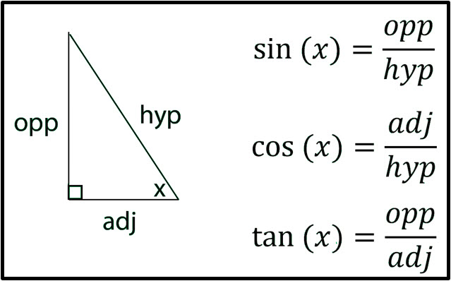

* Use the inverse sine (arcsin), inverse cosine (arccos), and inverse tangent(arctan) to find the measure of an angle in a triangle.
* Know that an **oblique** triangle is a triangle that does **not** contain a right angle.
* Use the **Law of Sines** to solve a right triangle **or** an oblique triangle when given AAS, ASA, or SSA (Ambiguous Case).
* Use the **Law of Cosines** to solve a right triangle **or** an oblique triangle when given SAS or SSS.

**Monday, 3.3.25**

**Discuss these previously assigned right trig problems:**

1)**Find the missing sides and angles.  
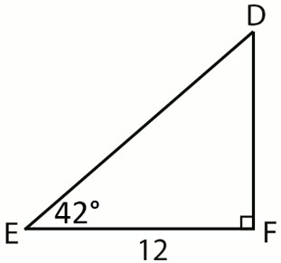**

2)**Find the missing sides and angles.  
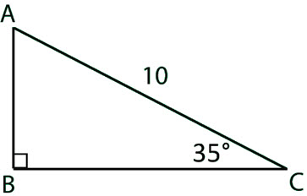**

3)**Find the missing sides and angles.  
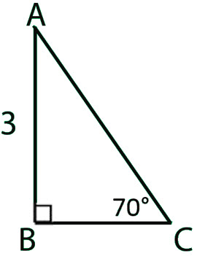**

4)**Express**cos 32∘**in terms of sine.**

5)**Express**sin 48∘**in terms of cosine.**

(6) The base of a ladder is placed 3 feet away from a 10 -foot-high wall, so that the top of the ladder meets the top of the wall. What is the measure of the angle formed by the ladder and the ground?

**Now, find angle *x* to the nearest tenth of a degree. ______________**

**Know that an oblique triangle** is a triangle that does **not** contain a right angle.

Use the **Law of Sines** to solve a right triangle or an oblique triangle when given AAS, ASA, or SSA (Ambiguous Case).

Use the **Law of Cosines** to solve an oblique triangle when given SAS or SSS.

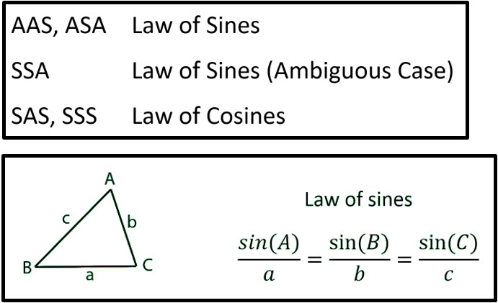

**Class Work/Homework: Use the The Law of Sines to solve the following problems:**

1. **ASA are given:** In ΔABC, C = 80º, B = 34º and a = 16.  
   Find side b to *nearest whole number.*
2. **AAS are given:** In ΔRST, R = 30º, T = 95º and r = 8.  
   Find *s* to *nearest tenth*.
3. **SSA** **are given**: In ΔABC, A = 30º, a = 7, and b = 16.  
   Find B to the nearest whole number.
4. **SSA are given:** In ΔABC, A = 30º, a = 20, and c = 16.  
   Find B to the nearest whole number.

**WEDNESDAY (3.5.25**)

**Discuss the 4 previously assigned problems.**

**Class Work/Homework: Handout (The Law of Sines)**

**Friday, 3.7.25**

**Discuss the previously assigned class work/homework: Law of Sines Handout.**

**Class Work/Homework:**

The Law of Cosines works for any triangle, both right triangles and oblique triangles, when you know SAS or SSS. The **Law of Cosines** (also called the **Cosine Rule**) is below:

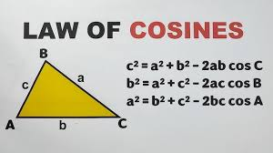

**Class Work/Homework:**

1. **SAS are given**: How long is side c, rounded to the nearest hundredth?

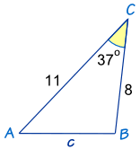

1. **SSS are given:** What is Angle C, rounded to the nearest tenth?

